I have now got code for the Two-Step Adams-Bashforth method which has the following computational stencil
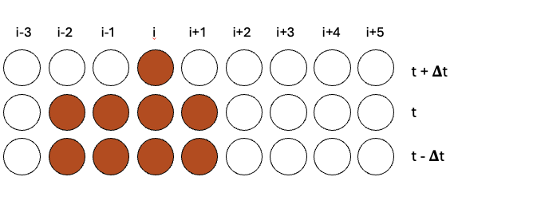
Using this exact stencil for the GETLM with the smallest 1 eigenvalue eigenvector being selected, I then compared it to the LETLM and IETLM with the following stencil
LETLM
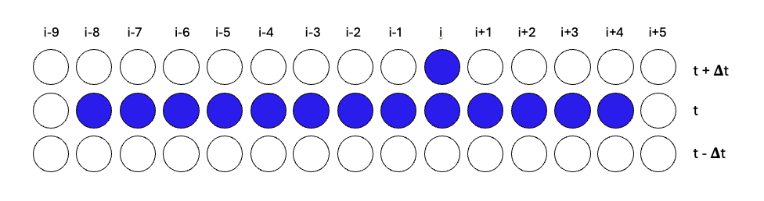
IETLM
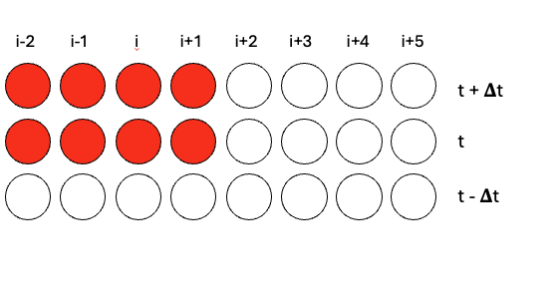
These are the results that I got
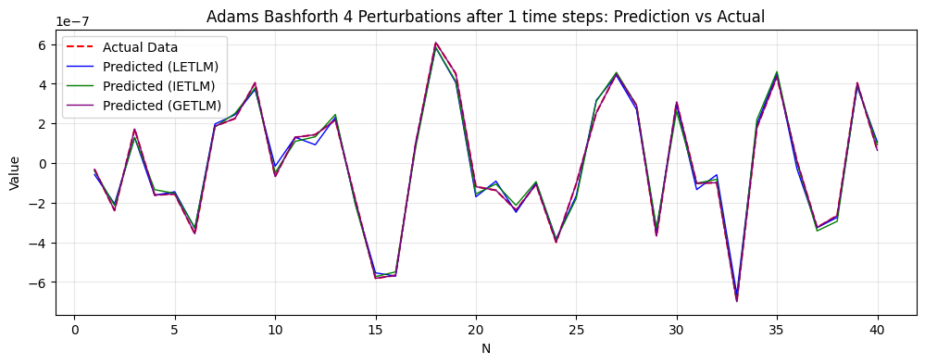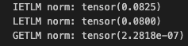
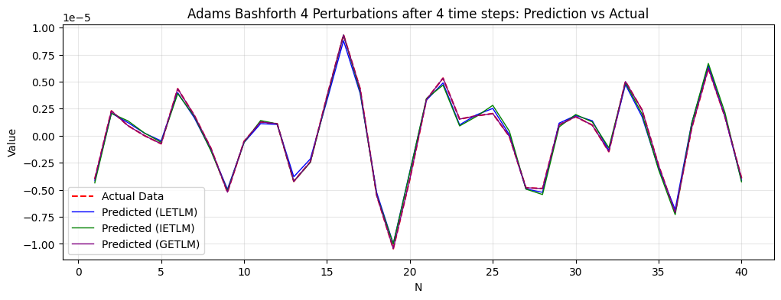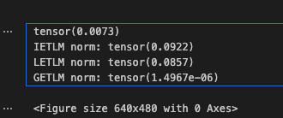
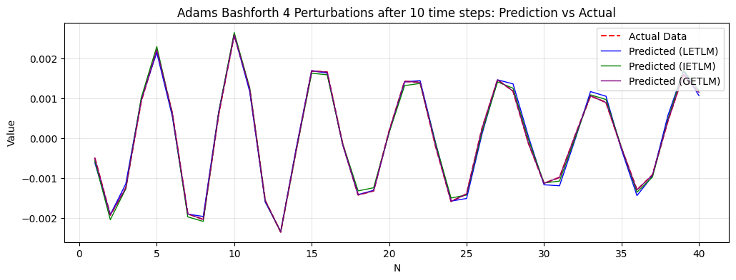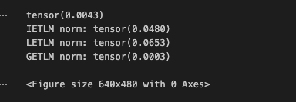
But then the GETLM becomes very unstable and explodes
What is quite interesting that the eigenvalue spectrum starts with a very separate zero-eigenvalue-eigenvector
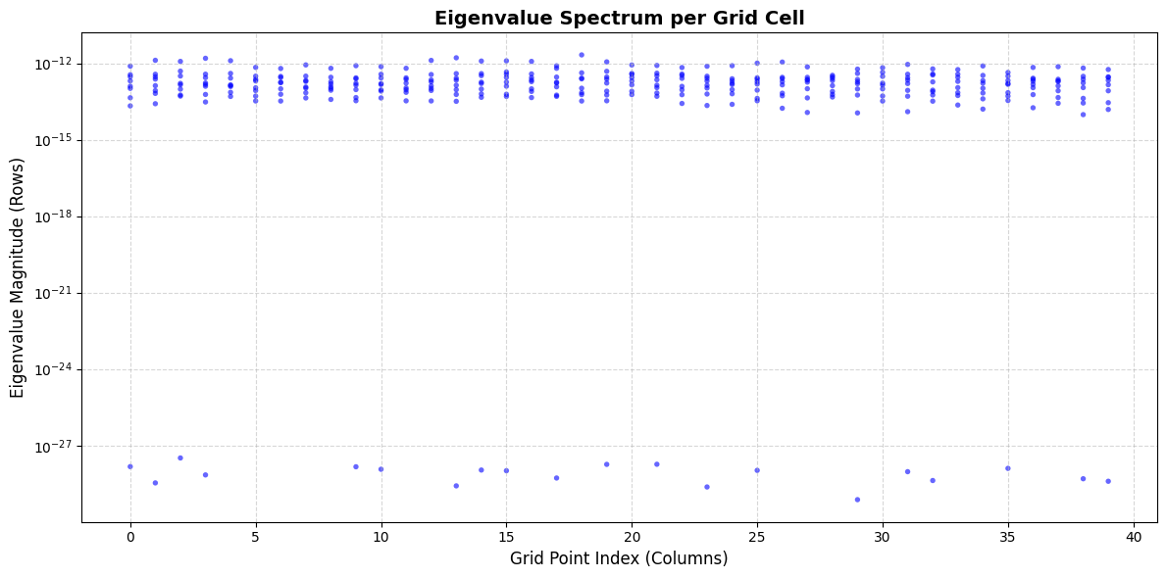
But by the 12 step, there is no longer a clear singular zero-eigenvalue eigenvector
